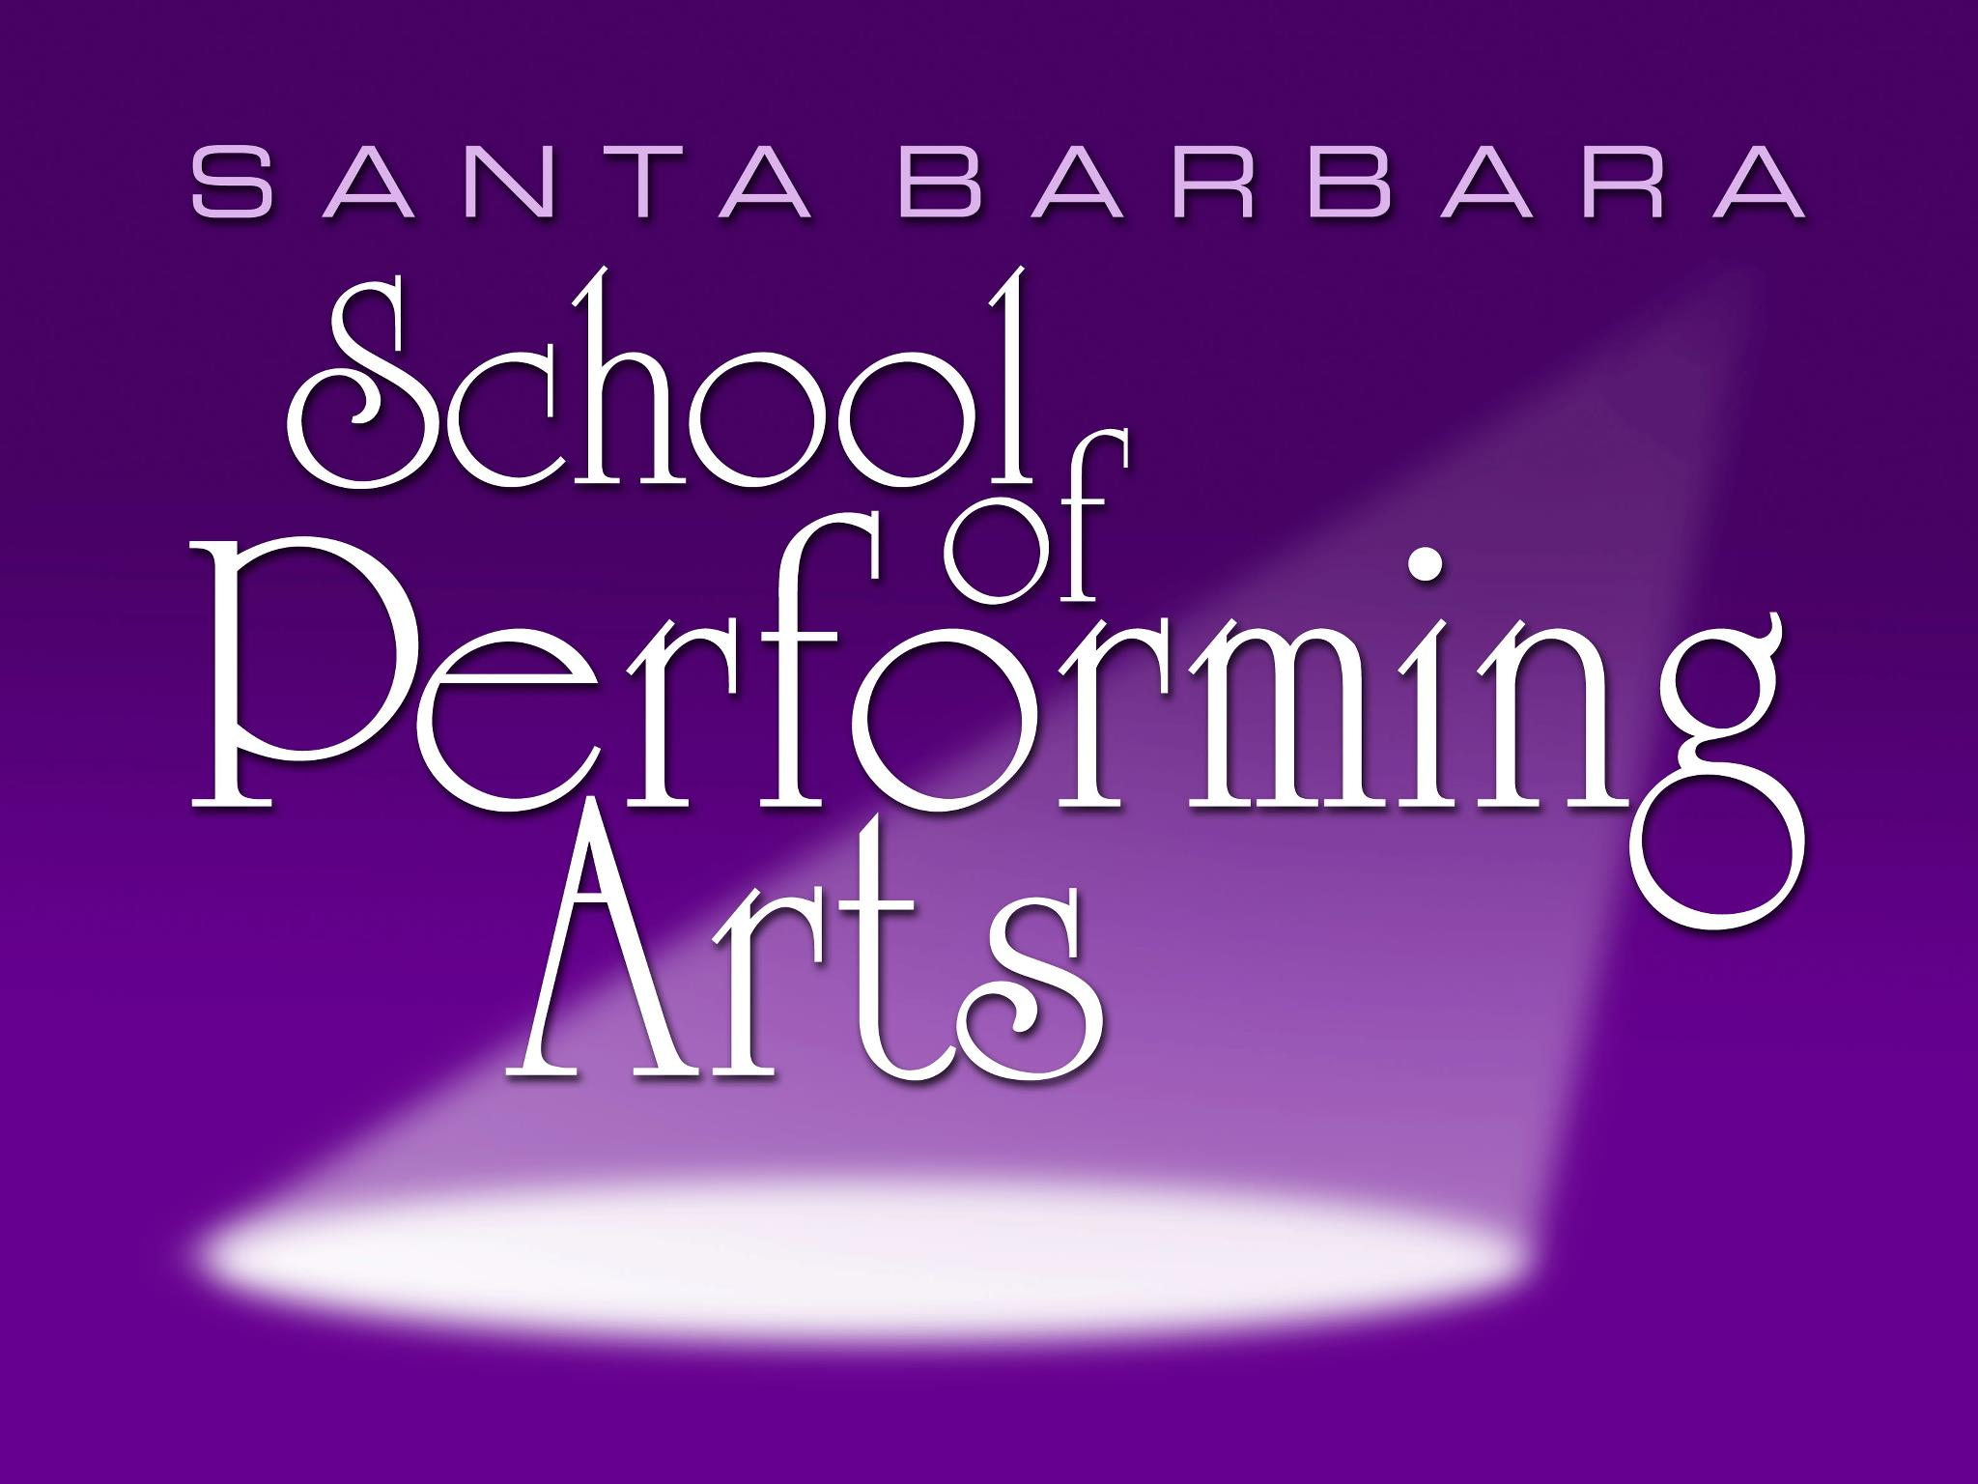

ALADDIN AUDITION APPLICATION

Date:
Name:
Mailing Address:
City: State/ZIP:
Actor’s Cellphone: Home or Parents’ Cell:
Actor’s Email Address: ____________________ Parent’s Email: _____________________
Formal Training (acting, voice, dance, technical, other)

Past Experience (name of show, part played, when, where, continue on separate page if needed)

Height: Weight:
Age: Gender:
Part or parts auditioning for:
Will you take another role, if offered?
Are you available as technical support?
If so, in what capacity?
Rehearsal conflict dates:

DIRECTOR’S COMMENTS (Do not write below this line)
General comments:
Voice:
Movement:
Technical help:
Other:

TURN OVER FOR PHOTO RELEASE
Photo Release Agreement for Performing & Visual Arts Camp
PVAC
27 W. Anapamu, #175
Santa Barbara, CA 93101

For those auditioning … if you are cast in a PVAC show, here are some things the Governing Board would like you to know about PVAC:

- Performing & Visual Arts Camp is a community, volunteer-based organization. As such, we do not pay actors, or provide reimbursement for mileage.

- PVAC plays run for 4 performances and “run-outs” to retirement homes up to 2 weeks prior to the show. These benefit performances, have not been finalized but PVAC will provide that info at least a week before the performances.

- During the run of each show, the cast and crew are responsible for keeping the theatre tidy for Jo Ann Caines Theatre patrons (this includes cleaning restrooms). Prior to opening night, the director will provide a list of housekeeping duties. They don’t take a lot of time, and the board appreciates your help in keeping our “home” a welcoming place for patrons.

- You authorize PVAC to use photographs or videos of you for promotional purposes in any type of media, including its website, without payment or any other consideration.

Please talk to the director or the artistic director if you have questions about these or other issues.
Please read the following carefully and sign below to indicate your agreement.

I grant to PVAC, its representatives the right to take photographs of me. I authorize SOPA, its assigns and transferees to copyright, use and publish the same in print and/or electronically.

I agree that Santa Barbara School of Performing Arts may use such photographs of me with or without my name and for any lawful purpose, including publicity, illustration, advertising, social media and the organization’s website.

I have read and understand the above:

Signature:
Printed name:
Date:

Parent or guardian of individual under age 18:
Signature:
Printed name:

